**Assignment – 3**

**Hit and Miss Rate in Caches**

**Project Report**

By: -

IMT2020553, Abhinav Mahajan

And

IMT2020539, Shaurya Agrawal

Summary: -

5 trace files given and corresponding code was written to answer questions which constraints cache size and block sizes.

Output: -Snapshots taken of output generated on terminal. **Output Table provided after output section.**

Format of output is for each question number. Cache size and block size are enumerated on top and hit and miss rates are printed for each trace file.

a.) Cache lines required is 64 * 1024 / 4 = 16,384 lines ( = 214 lines)

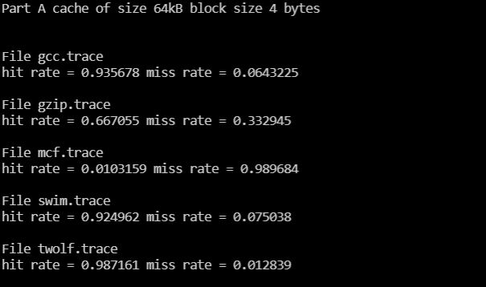

b.) Cache lines required is 512 * 1024 / 4 = 131,072 lines ( = 217 lines)

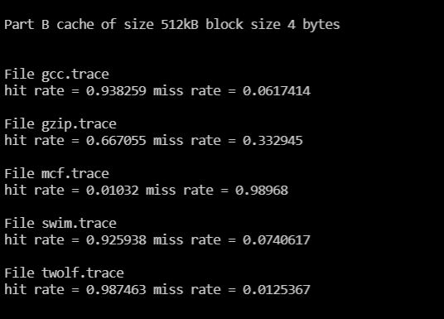

c.) for block size 1 byte: -

Cache lines required is 64 * 1024 / 1 = 65,536 lines ( = 216 lines)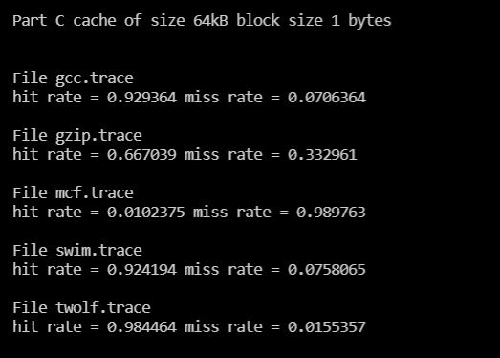

For block size 4 bytes (same as question a): -

Cache lines required is 64 * 1024 / 4 = 16,384 lines ( = 214 lines)

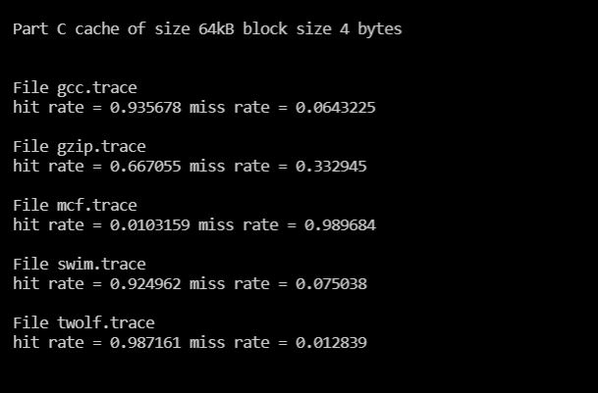

For block size 8 bytes: -

Cache lines required is 64 * 1024 / 8 = 8,192 lines ( = 213 lines)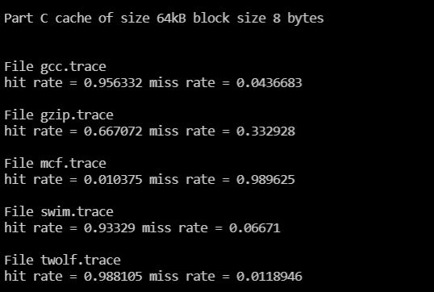

For block size 16 bytes: -

Cache lines required is 64 * 1024 / 16 = 4,096 lines ( = 212 lines)

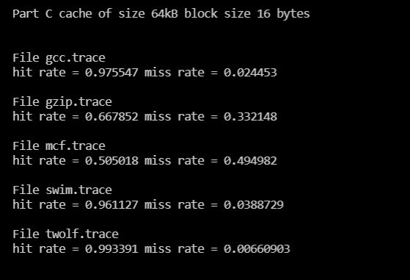

For block size 32 bytes: -

Cache lines required is 64 * 1024 / 32 = 2,048 lines ( = 211 lines)

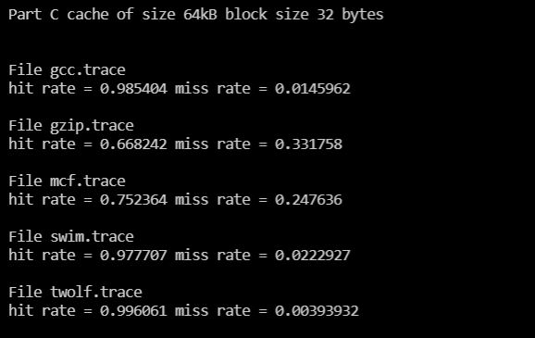

**Trace files**

**Hit rate %/Miss rate % format in table entry**

**Hit and miss rates rounded up to nearest integer**

|  |  |  |  |  |  |
| --- | --- | --- | --- | --- | --- |
| **Question number and number of cache lines** | **gcc.trace** | **gzip.trace** | **mcf.trace** | **swim.trace** | **twolf.trace** |
| a.) 214 lines | 94/6 | 67/33 | 1/99 | 92/8 | 99/1 |
| b.) 217 lines | 94/6 | 67/33 | 1/99 | 93/7 | 99/1 |
| c.), 1 byte block, 216 lines | 93/6 | 67/33 | 1/99 | 92/8 | 98/2 |
| c.), 4 byte block, 214 lines | 94/6 | 67/33 | 1/99 | 92/8 | 99/1 |
| c.), 8 byte block, 213 lines | 96/4 | 67/33 | 1/99 | 93/7 | 99/1 |
| c.), 16 byte block, 212 lines | 98/2 | 67/33 | 51/49 | 96/4 | 99/1 |
| c.) 32 bye block, 211 lines | 99/1 | 67/33 | 75/25 | 99/1 | 99/1 |

Observations interpreted from the result will be presented in demo.